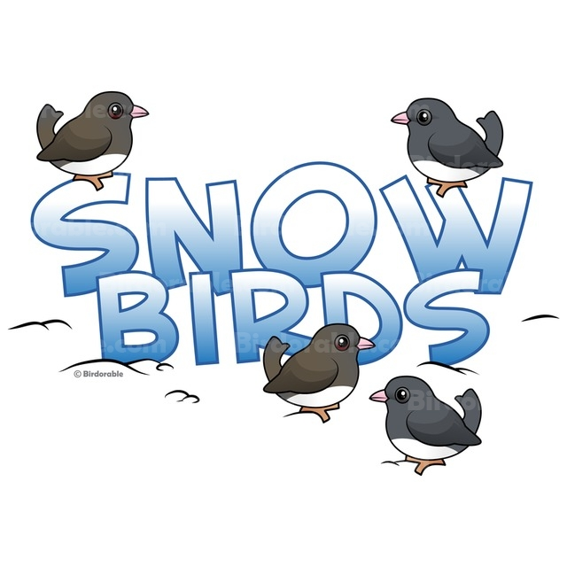
Are you a snow bird??? Please let us know so that we can send your sewer and water bills to you while you are away. Please complete and return.
Thank you!!!!!!

Name: __________________________________________________
Property Location: _____________________________________

Alternate mailing address: __________________________
__________________________
__________________________
__________________________
Contact Phone # ___________________________
Months you are away: ___________________________
ex: Oct – April

Return to:

Berlin Township Tax Office
135 Route 73 South
West Berlin, NJ 08091

